EECE 5354 Computer Vision

Assignment 2: Feature Detection and Matching

Shrey Shah

2nd March 2019

# Introduction

Feature Detection is basically finding key points or pixels in the image. Key points in an image are unique points in a local section of the image which can be found and matched to corresponding points in other images. Many computer vision algorithms use feature detection as the initial step, so as a result, a very large number of feature detectors have been developed. The following feature detectors were studied during this assignment:

1. Harris Corner Detection: Given by Chris Harris and Mike Stephens, it basically finds the difference in intensity for a displacement of (*u, v*) in all directions and uses this to find corners. A score, calculated using a function on two eigen values, is determined for each pixel, and if the score is above a certain value, the pixel is marked as a corner. The score is calculated using two eigenvalues.
2. Shi – Tomasi Corner Detector: This detection algorithm builds on the Harris detector by making a small modification to the selection criteria for the corners. Shi and Tomasi suggested only the eigen values should be used to check whether a pixel is corner or not, instead of a function on the eigen values to generate a score. The slight variation made the detector much better than the original, determining features even where the Harris Corner Detector failed.
3. SIFT Feature Detection: The Harris corner detection is rotation invariant but not scale invariant. Scale Invariant Feature Transform (SIFT) given by D. Lowe, is a scale invariant algorithm which extracts keypoints from an image and computes their descriptors. The algorithm determines the scale space by approximating the Laplacian of Gaussian by Difference of Gaussian.
4. SURF Feature Detection: Speeded Up Robust Features (SURF) is a speeded-up version of the SIFT algorithm which uses box filter to approximate the Laplacian of the Gaussian to determine the scale space. As a result, the convolution with the box filter can be easily calculated using the integral images. In addition to this, the SURF algorithm relies on the determinant of Hessian Matrix for both scale and location
5. FAST algorithm for corner detection: Proposed by Edward Rosten and Tom Drummond, Features from Accelerated Segment Test (FAST) algorithm is a very fast algorithm for keypoint detection and hence can be applied to real-time applications. FAST corner detector uses a circle of 16 pixels (a Bresenham circle of radius 3) to classify whether a candidate point p is a corner.
6. BRIEF Algorithm: Binary Robust Independent Elementary Features is a feature descriptor. It provides the descriptors of features in the image as binary strings rather than floating point, saving a lot of memory. These binary strings are used to match features using the Hamming Distance, providing a better speed up over other algorithms.
7. ORB Algorithm: Oriented FAST and Rotated BRIEF, is a combination of the FAST algorithm for keypoint detection and BRIEF algorithm for determining the descriptors, along with modifications to further enhance the performance of the algorithm.

The algorithms mentioned above determine the features along with the descriptors of the feature in an image. Feature matching uses this information to match features across different images. In this assignment we have used the Brute-Force Matcher to perform the matching between the images. The algorithm behind Brute-Force Matcher is simple: It takes the descriptor of one feature in first set and is matched with all other features in second set using some distance calculation. And the closest one is returned.

Another very important feature descriptor used in computer vision is the Histogram of Oriented Gradients (HoG) feature Descriptor. The basic idea behind this algorithm is that local object appearance and shape can often be characterized rather well by the distribution of local intensity gradients or edge directions, even without precise knowledge of the corresponding gradient or edge positions. In the graduate part of this assignment the HoG feature Descriptor is used to implement a Handwriting Recognition application.

# Harris Corner Detection

**1.1 Description**

Given by Chris Harris and Mike Stephens, it basically finds the difference in intensity for a displacement of (*u, v*) in all directions and uses this to find corners. This is expressed as below:

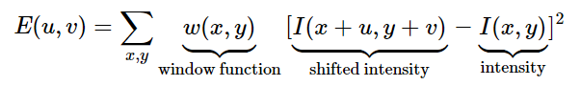

Window function is either a rectangular window or gaussian window which gives weights to pixels underneath. We have to maximize this function E(u, v) for corner detection. That means, we must maximize the second term. Applying Taylor Expansion to above equation and using some mathematical steps, we get the final equation as:

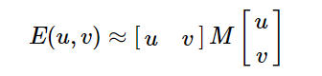

where

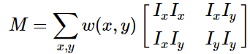

Here, Ix and Iy are image derivatives in x and y directions respectively.

Then comes the main part. After this, they created a score, basically an equation, which will determine if a window can contain a corner or not.

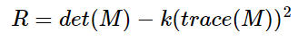

where

* det(M)=λ1λ2
* trace(M)=λ1+λ2
* λ1 and λ2 are the eigen values of M

So, the values of these eigen values decide whether a region is corner, edge or flat.

* When |R| is small, which happens when λ1 and λ2 are small, the region is flat.
* When R<0, which happens when λ1>>λ2 or vice versa, the region is edge.
* When R is large, which happens when λ1 and λ2 are large and λ1∼λ2, the region is a corner.

Commonly, Harris corner detector algorithm can be divided into five steps.

1. Color to grayscale
2. Spatial derivative calculation
3. Structure tensor setup
4. Harris response calculation
5. Non-maximum suppression

OpenCV provides the function cv2.cornerHarris() for implementing the Harris Corner detection. Its arguments are:

* img - Input image, it should be grayscale and float32 type.
* blockSize - It is the size of neighbourhood considered for corner detection
* ksize - Aperture parameter of Sobel derivative used.
* k - Harris detector free parameter in the equation.

The code implementing the Harris Corner Detector is given in the Appendix.

**1.2 Parameter Choice**

For this assignment the following parameter values were selected:

blocksize = 2

ksize = 3

k = 0.04

These parameters were selected as they provided the best feature detection for the image used.

**1.3 Results**

The images used as the input for this assignment are shown in fig. 1 and fig.2. The first image is referred to as the I_left and the second image is referred to as I_st throughout the assignment.

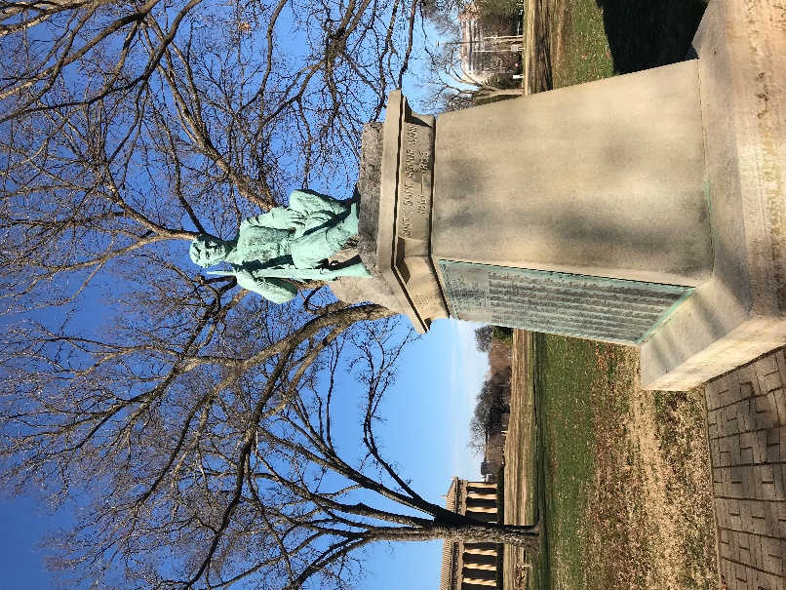

Figure.1. Input Image 1 – I_left

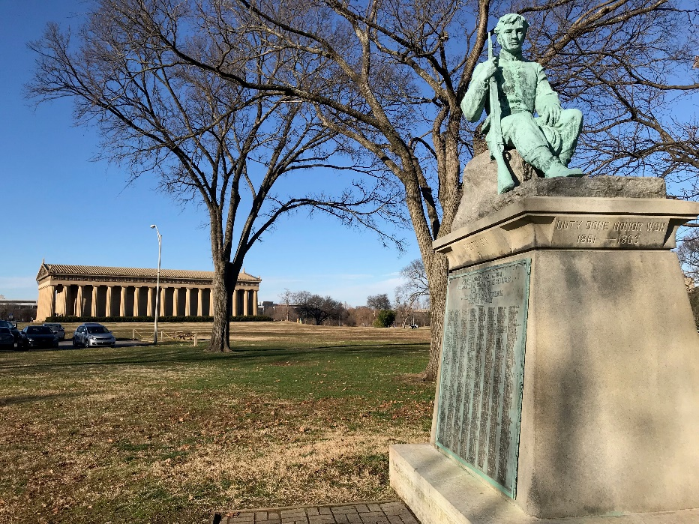

Figure.2. Input Image 2 – I_st

Results of Harris Corner Detection on the input Images are shown in fig. 3 and fig. 4.

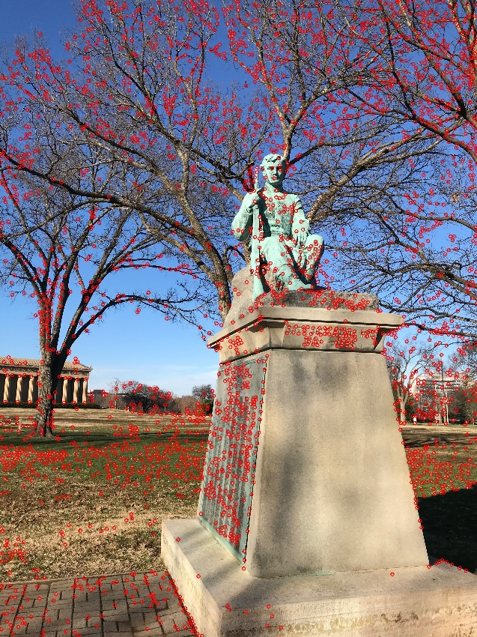

Figure 3. 1st Input Image - I_left with Keypoints as detected by Harris Corner Detector

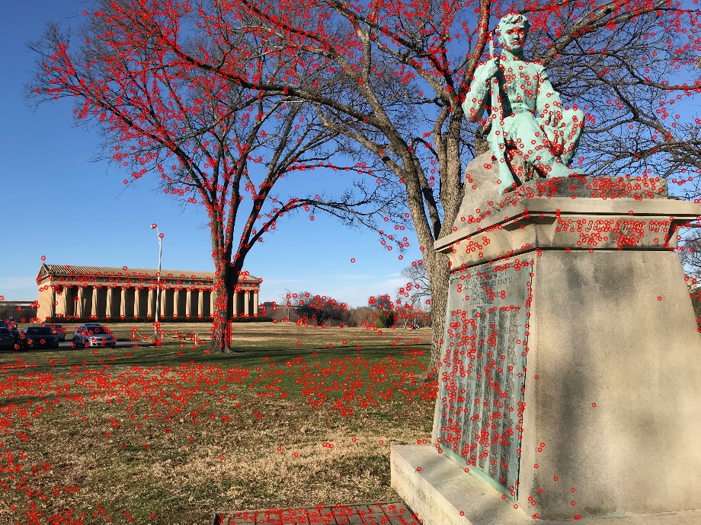

Figure 4. 2nd Input Image – I_st with Keypoints as detected by Harris Corner Detector

Result of matching between the two input images - I_left and I_st after performing Harris Feature Detection is shown in fig. 5.

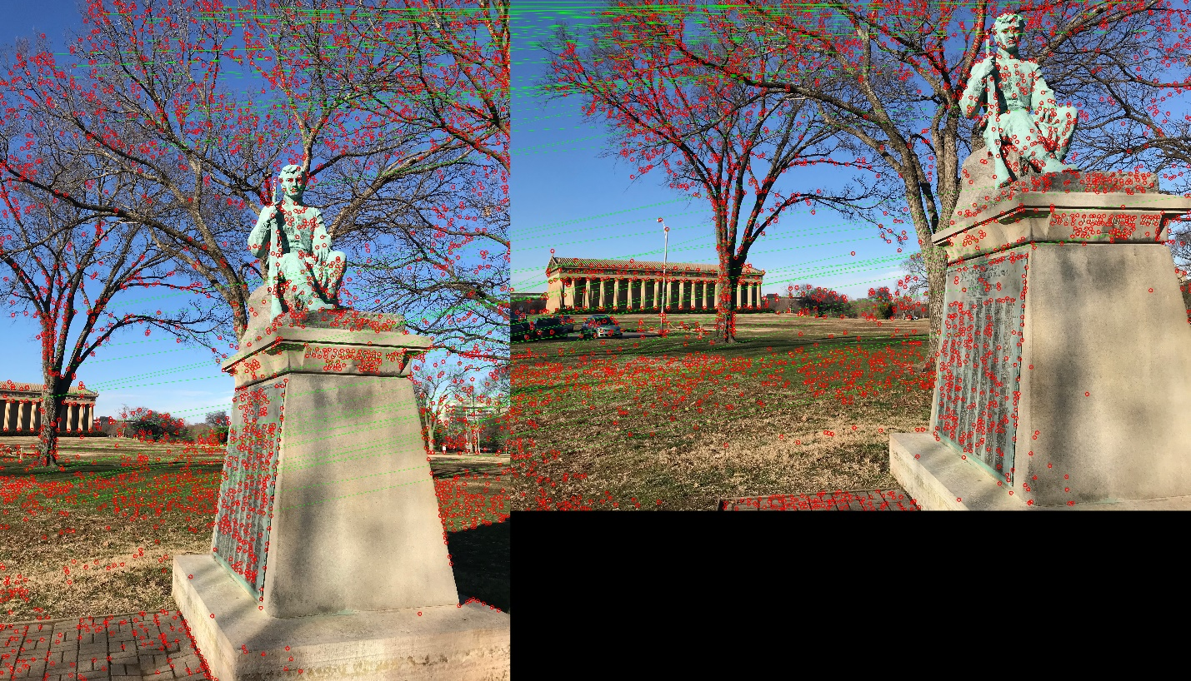

Figure 5. Results of Matching after Harris Feature Detector

**1.4 Discussion of Results**

After analyzing the results, it is evident that Harris Corner Detection algorithm successfully finds the corners in the image. The matching performed after generating the keypoints and the descriptors is also very good. Although some of the points match to the wrong point during matching, but most of the points match correctly. Hence, the keypoints and descriptors generated using Harris Corner Detection algorithm provids good matching between the images.

# Shi - Tomasi Corner Detection

**2.1 Description**

This detection algorithm builds on the Harris detector by making a small modification to the selection criteria for the corners. The scoring function in Harris Corner Detector was given by:

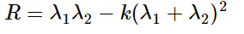

Instead of this, Shi-Tomasi proposed:

R = min(λ1, λ2)

If it is a greater than a threshold value, it is considered as a corner.

OpenCV provides the function cv2.goodFeaturesToTrack() which implements the Shi-Tomasi algorithm to find the best N corners in the image. The code implementing the Shi-Tomasi algoritm is given in the Appendix.

**2.2 Parameter Selection**

For this assignment the following parameter values were selected:

maxCorners = 1000

qualityLevel = 0.1

minDistance = 50

The maxCorners was set at 1000 so that the function detects only 500 corners (for clarity in the image). The qualityLevel was set at 0.1 so that the corners with qualityLevel less than 0.1 are rejected by the function. The minDistance determines the minimum Eucledian distance between the corners detected by the function, which is set to 50.

**2.3 Results**

The result of the Shi-Tomasi Corner Detector on the 1st Input Image – I_left is shown in fig. 6 and on 2nd Input Image – I_st is shown in fig. 7

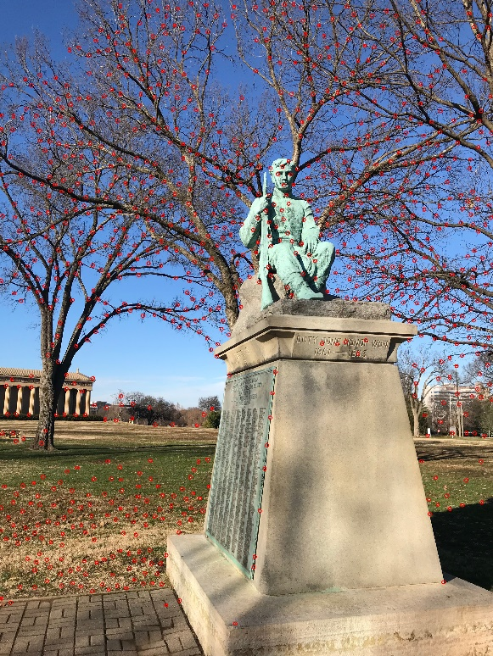

Figure. 6. Shi-Tomasi on I_left

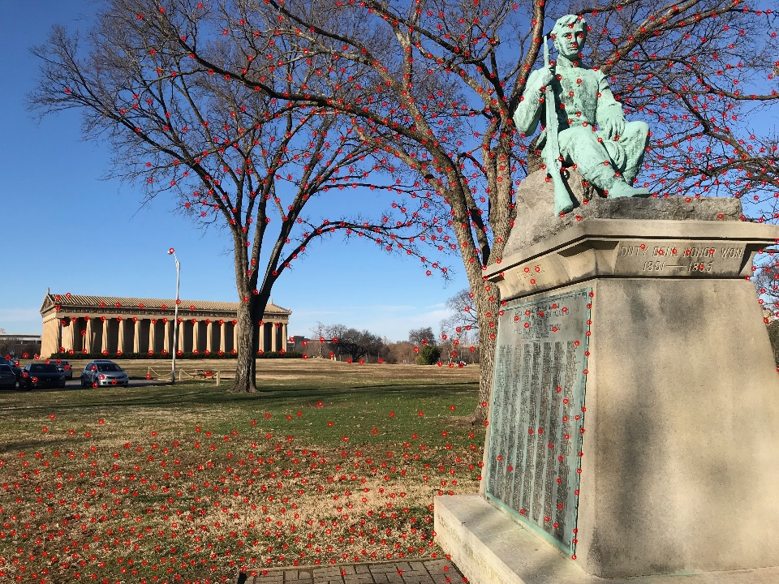

Figure. 7 Result of Shi-Tomasi Feature Detector on I_st

The result of Feature matching, after applying Shi-Tomasi feature detection algorithm, performed between 1st Input Image and 2nd Input Image is shown in fig. 8.

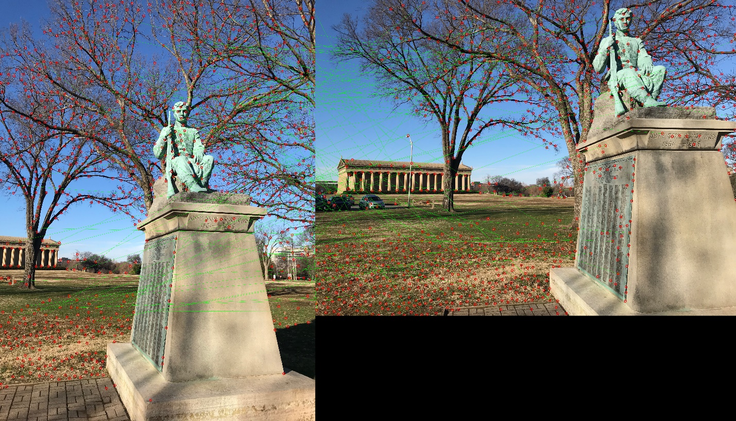

Figure 8. Results of Matching after Shi - Tomasi Feature Detector

**2.4 Discussion of Results**

After observing the results, it is evident that the Shi – Tomasi Feature Detection Algorithm provides good feature detection in the image. But the matching performed after generating the keypoints and descriptors of the image is not very good. Although, some points match correctly across the two images, more than half of the points are incorrectly matched. Hence, it is not providing good matching between images.

# SIFT

**3.1 Description**

SIFT can robustly identify objects even among clutter and under partial occlusion, because the SIFT feature descriptor is invariant to uniform scaling, orientation, illumination changes, and partially invariant to affine distortion. There are mainly four steps involved in SIFT algorithm.

1. Scale Space Extrema Detection:

To detect larger corners scale-space filtering is used. In it, Laplacian of Gaussian is found for the image with various σ values. LoG acts as a blob detector which detects blobs in various sizes due to change in σ. In short, σ acts as a scaling parameter. So, we can find the local maxima across the scale and space which gives us a list of (x,y,σ) values which means there is a potential keypoint at (x,y) at σ scale.

But this LoG is a little costly, so SIFT algorithm uses Difference of Gaussians which approximates LoG. Difference of Gaussian is obtained as the difference of Gaussian blurring of an image with two different σ, let it be σ and kσ. This process is done for different octaves of the image in Gaussian Pyramid. Once this DoG are found, images are searched for local extrema over scale and space. If it is a local extrema, it is a potential keypoint. It basically means that keypoint is best represented in that scale.

1. Keypoint Localization:

Once potential keypoints locations are found, they have to be refined to get more accurate results. They used Taylor series expansion of scale space to get more accurate location of extrema, and if the intensity at this extrema is less than a threshold value (0.03 as per the paper), it is rejected. This threshold is called contrastThreshold in OpenCV

DoG has higher response for edges, so edges also need to be removed. For this, a concept similar to Harris corner detector is used. They used a 2x2 Hessian matrix (H) to compute the principal curvature. We know from Harris corner detector that for edges, one eigen value is larger than the other. So here they used a simple function,

If this ratio is greater than a threshold, called edgeThreshold in OpenCV, that keypoint is discarded.

1. Orientation Assignment:

Now an orientation is assigned to each keypoint to achieve invariance to image rotation. A neighbourhood is taken around the keypoint location depending on the scale, and the gradient magnitude and direction is calculated in that region. An orientation histogram with 36 bins covering 360 degrees is created (It is weighted by gradient magnitude and gaussian-weighted circular window with σ equal to 1.5 times the scale of keypoint). The highest peak in the histogram is taken and any peak above 80% of it is also considered to calculate the orientation. It creates keypoints with same location and scale, but different directions. It contributes to stability of matching.

1. Keypoint Descriptor:

Now keypoint descriptor is created. A 16x16 neighbourhood around the keypoint is taken. It is divided into 16 sub-blocks of 4x4 size. For each sub-block, 8 bin orientation histogram is created. So, a total of 128 bin values are available. It is represented as a vector to form keypoint descriptor. In addition to this, several measures are taken to achieve robustness against illumination changes, rotation etc.

1. Keypoint Matching:

Keypoints between two images are matched by identifying their nearest neighbours. But in some cases, the second closest-match may be very near to the first. It may happen due to noise or some other reasons. In that case, ratio of closest-distance to second-closest distance is taken. If it is greater than 0.8, they are rejected.

OpenCV provides the function cv2.xfeatures2d.SIFT_create() which creates object of SIFT. The code implementing the SIFT algorithm is given in the Appendix.

* 1. **Parameter Selection**

For this assignment the following parameters were passed while creating the SIFT object of cv2:

contrastThreshold = 0.16

sigma = 1.2

Rest of the parameters had the default values.

contrastThreshold was set at 0.16 to reduce the number of keypoints detected by the SIFT algorithm. Sigma was set at 1.2 as the photos were taking by a low-quality camera.

* 1. **Results**

The results of keypoint detection by SIFT algorithm on the input images are shown in fig. 9 and fig. 10.

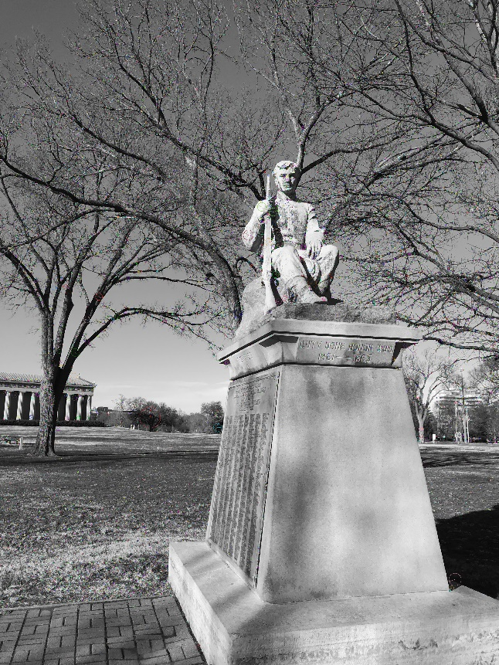

Figure 9. I_left marked with keypoints detected by SIFT

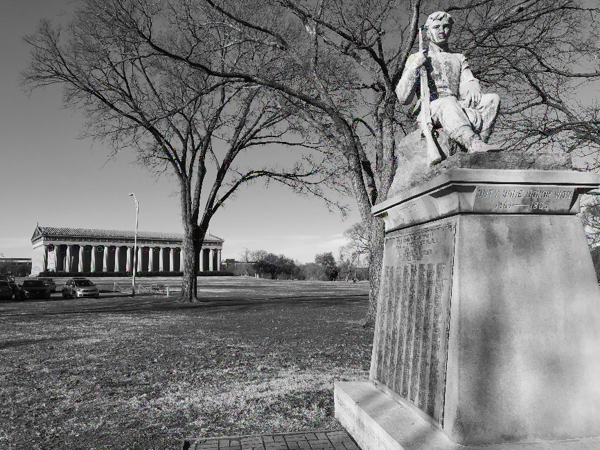

Figure 10. I_st marked with keypoints detected by SIFT

Note: The features are present but are not completely visible in the report. Please view the attached output images with the submission.

The result of feature matching between the two images, after applying SIFT on them is shown in fig. 11.

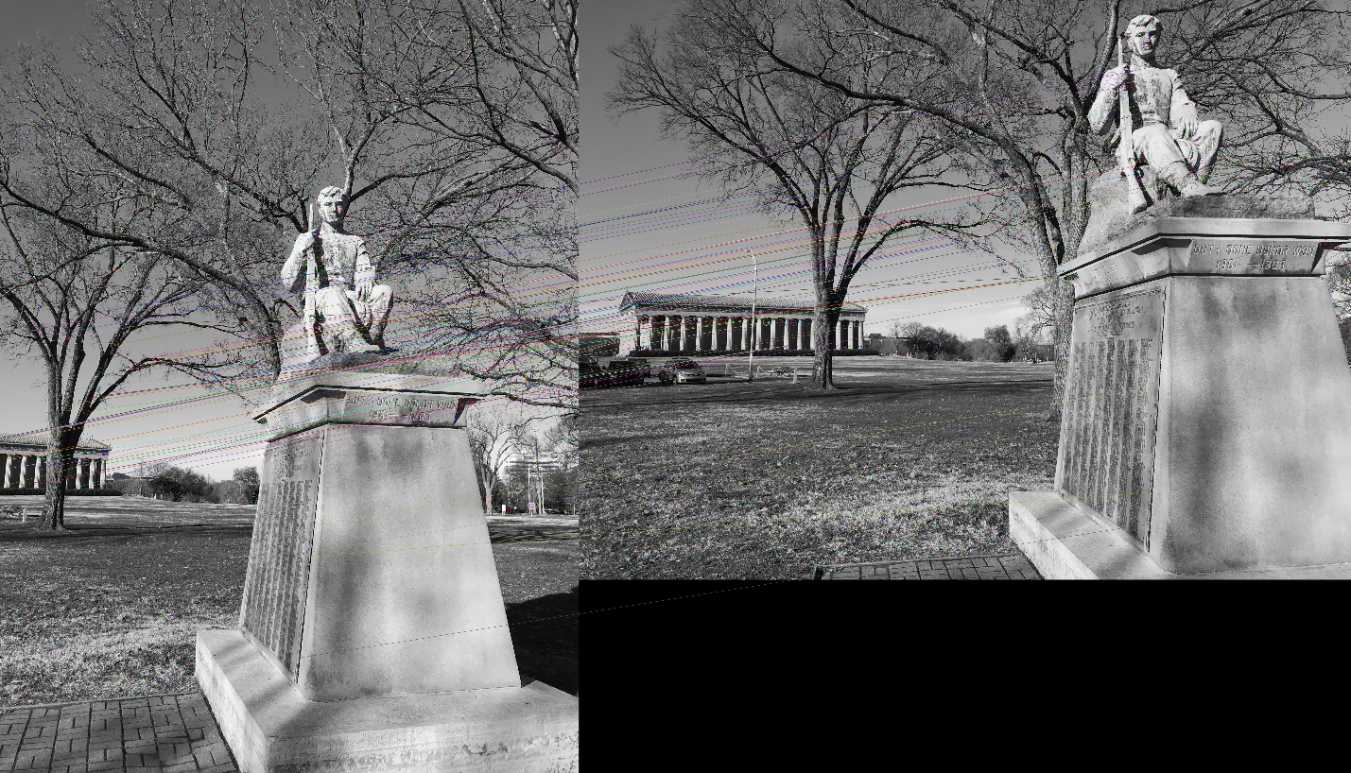

Figure 11. Matching between I_left and I_st after applying SIFT algorithm

* 1. **Discussion of Results**

After analyzing the results generated by the SIFT algorithm, it is evident that SIFT performs very good feature detection in images. It is also observed that the SIFT algorithm along with the BFMatcher does an excellent job in matching the keypoints between the two images. Majority of the keypoints have been matched accurately and only a few have been matched incorrectly. Hence the SIFT Algorithm performs very good feature matching across images.

# SURF

**4.1 Description**

Speeded Up Robust Features (SURF) is a speeded-up version of the SIFT algorithm which uses box filter to approximate the Laplacian of the Gaussian to determine the scale space. As a result, the convolution with the box filter can be easily calculated using the integral images. In addition to this, the SURF algorithm relies on the determinant of Hessian Matrix for both scale and location.

For orientation assignment, SURF uses wavelet responses in horizontal and vertical direction for a neighbourhood of size 6s. Adequate gaussian weights are also applied to it. The dominant orientation is estimated by calculating the sum of all responses within a sliding orientation window of angle 60 degrees. Interesting thing is that, wavelet response can be found out using integral images very easily at any scale.

For feature description, SURF uses Wavelet responses in horizontal and vertical direction (again, use of integral images makes things easier). This when represented as a vector gives SURF feature descriptor with total 64 dimensions. Lower the dimension, higher the speed of computation and matching, but provide better distinctiveness of features.

Another important improvement is the use of sign of Laplacian (trace of Hessian Matrix) for underlying interest point. It adds no computation cost since it is already computed during detection. The sign of the Laplacian distinguishes bright blobs on dark backgrounds from the reverse situation. In the matching stage, we only compare features if they have the same type of contrast.

In short, SURF adds a lot of features to improve the speed in every step. Analysis shows it is 3 times faster than SIFT while performance is comparable to SIFT. SURF is good at handling images with blurring and rotation, but not good at handling viewpoint change and illumination change.

OpenCV provides the function cv2.xfeatures2d.SURF_create() which creates object of SIFT. The code implementing the SURF Algorithm is given in the Appendix.

**4.2 Parameter Selection**

For this assignment the following parameters were passed while creating the SURF object of cv2:

HessianThreshold = 5000

Rest of the parameters were set at the default values.

The threshold for the Hessian Detector used in SURF for detecting the keypoints was set at 5000 to limit the number of keypoints detected in the image.

**4.3 Results**

The results of keypoint detection by SURF algorithm on the input images are shown in fig. 12 and fig. 13.

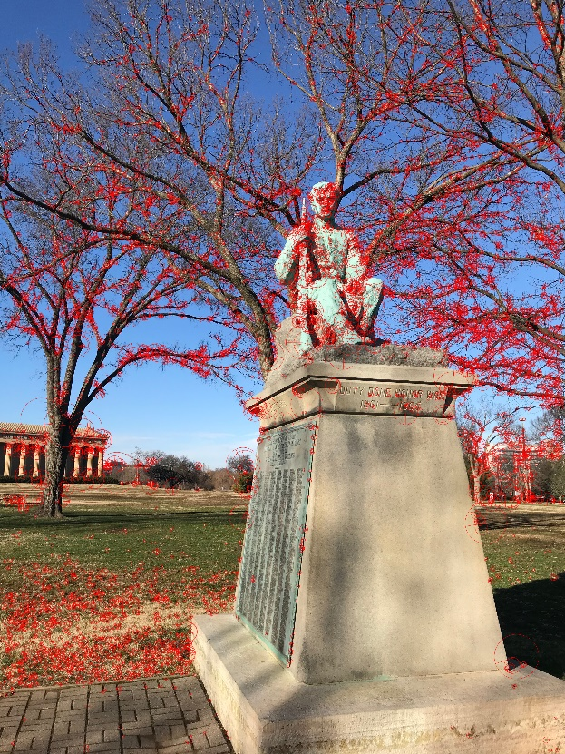

Figure 12. I_left marked with keypoints detected by SURF

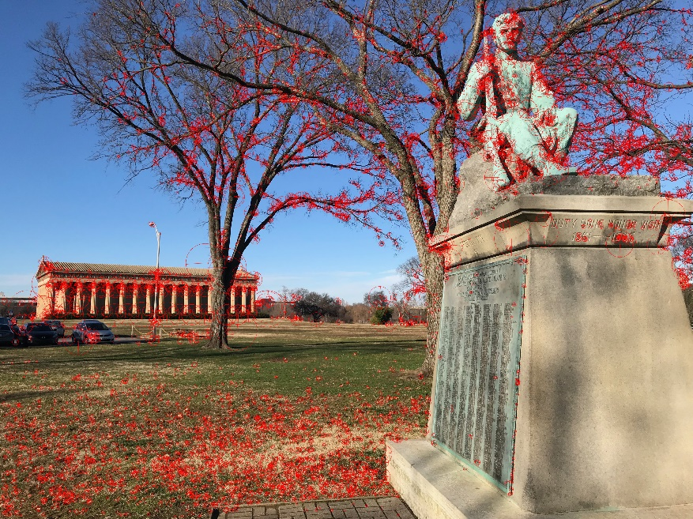

Figure 13. I_st marked with keypoints detected by SURF

The result of feature matching between the two images, after applying SURF on them is shown in fig. 14.

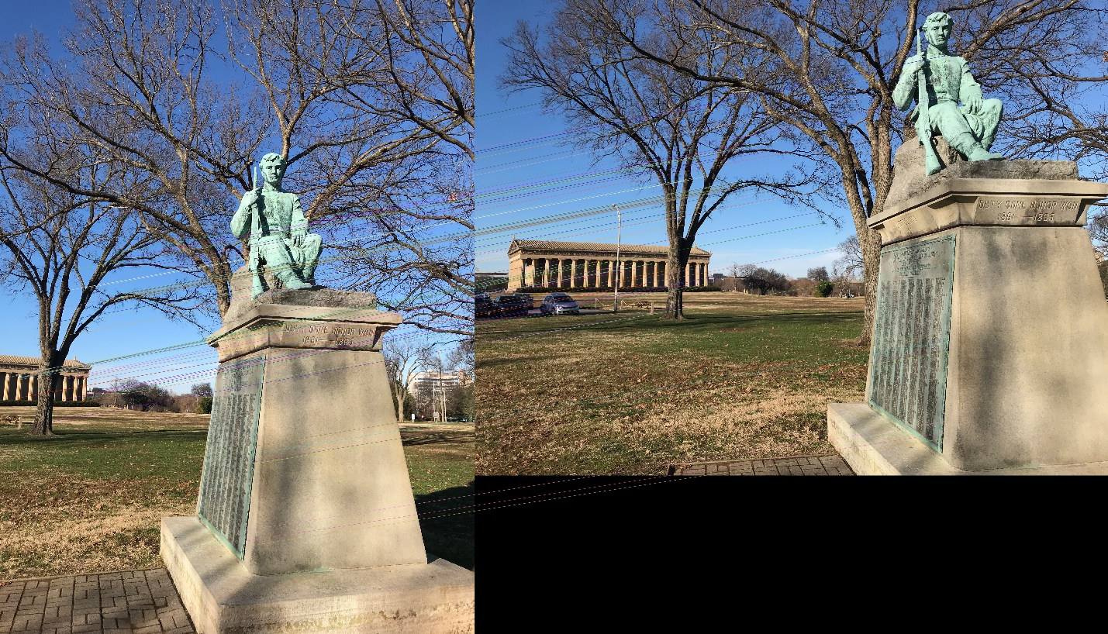

Figure. 14 Matching Between I_left and I_st after implementing SURF Algorithm

* 1. **Discussion of Results**

After observing the resultant images, it is evident that the SURF algorithm along with the BFMatcher does an excellent job in matching the keypoints between the two images. Like SIFT, majority of the keypoints have been matched accurately across the images. It was also observed that SURF was a little faster than SIFT for almost identical results. Hence SURF algorithm performs very good feature detection as well as feature matching.

# FAST

**5.1 Description**

Proposed by Edward Rosten and Tom Drummond, Features from Accelerated Segment Test (FAST) algorithm is a very fast algorithm for keypoint detection and hence can be applied to real-time applications. FAST corner detector uses a circle of 16 pixels (a Bresenham circle of radius 3) to classify whether a candidate point p is a corner. Each pixel in the circle is labeled from integer number 1 to 16 clockwise. If a set of N contiguous pixels in the circle are all brighter than the intensity of candidate pixel p (denoted by Ip) plus a threshold value t or all darker than the intensity of candidate pixel p minus threshold value t, then p is classified as corner. The conditions can be written as:

1. Condition 1: A set of N contiguous pixels S, ∀ x ∈ S, the intensity of x (Ix) > Ip + threshold t
2. Condition 2: A set of N contiguous pixels S, ∀ x ∈ S, Ix < Ip - t

So, when either of the two conditions is met, candidate p can be classified as a corner. There is a tradeoff of choosing N, the number of contiguous pixels and the threshold value t.

The high-speed test for rejecting non-corner points is operated by examining 4 example pixels, namely pixel 1, 9, 5 and 13. Because there should be at least 12 contiguous pixels that are whether all brighter or darker than the candidate corner, so there should be at least 3 pixels out of these 4 example pixels that are all brighter or darker than the candidate corner. Firstly pixels 1 and 9 are examined, if both I1 and I9 are within [Ip - t, Ip + t], then candidate p is not a corner. Otherwise pixels 5 and 13 are further examined to check whether three of them are brighter than Ip + t or darker than Ip - t. If there exists 3 of them that are either brighter or darker, the rest pixels are then examined for conclusion.

This detector exhibits high performance, but there are several weaknesses:

1. It does not reject as many candidates for n < 12.
2. The choice of pixels is not optimal because its efficiency depends on ordering of the questions and distribution of corner appearances.
3. Results of high-speed tests are thrown away.
4. Multiple features are detected adjacent to one another.

First 3 points are addressed with a machine learning approach. Last one is addressed using non-maximal suppression. The code implementing the FAST algorithm is given in appendix.

* 1. **Parameter Selection**

The following parameters were passed while creating the FAST object of cv2:

threshold = 80

Rest of the parameters are set at their default values

* 1. **Results**

The results of keypoint detection by FAST algorithm on the input images are shown in fig. 15 and fig. 16.

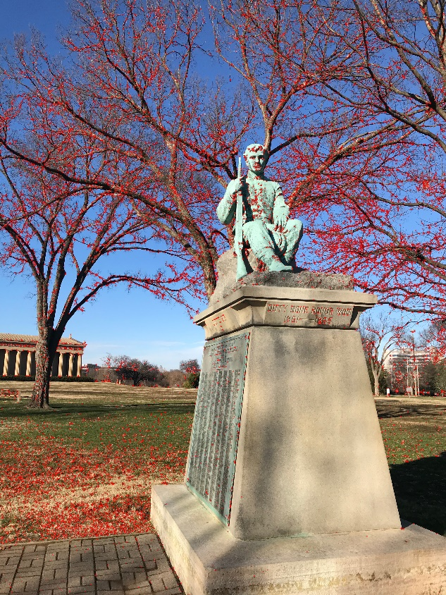

Figure 15. I_left marked with keypoints detected by SURF

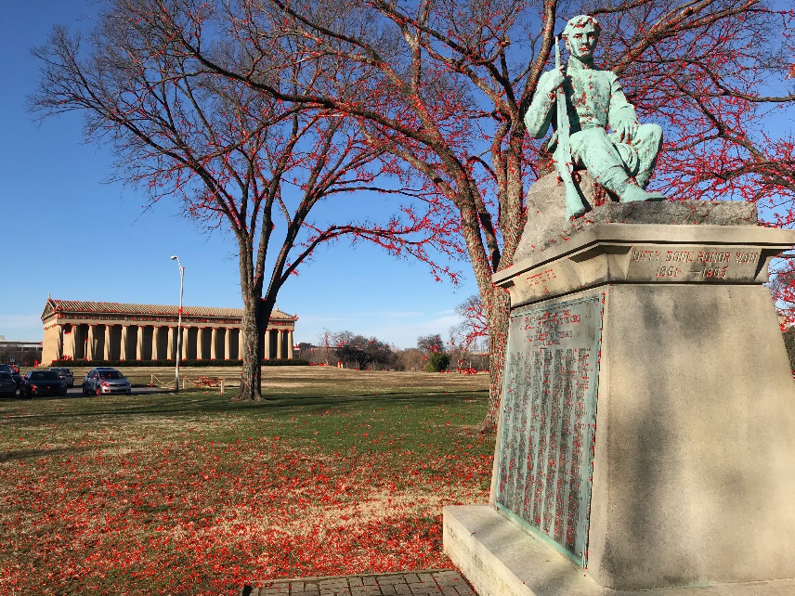

Figure 16. I_st marked with keypoints detected by FAST

The result of feature matching between the two images, after applying FAST on them to get the keypoints and BRIEF algorithm on them to get the descriptors, is shown in fig. 17.

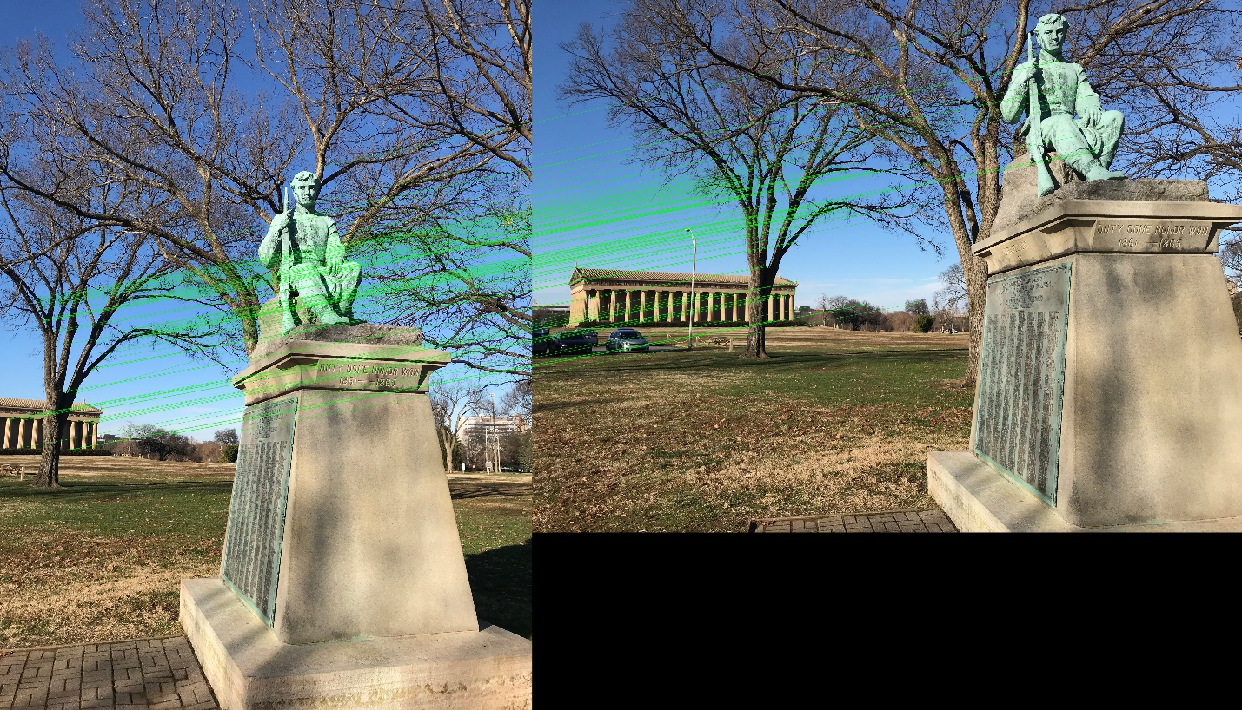

Figure. 17 Matching Between I_left and I_st after implementing FAST Algorithm

* 1. **Discussion of Results**

After analyzing the results, it is observed that the FAST algorithm performs very good feature detection and was considerably faster than other algorithms for almost identical results. For feature matching, as FAST algorithm does not generate descriptors, the descriptors for the keypoints were generated by using the BRIEF algorithm. The matching of features by using FAST and BRIEF with BFMatcher() was very good. Large number of points were matched accurately. But it can be observed that there are some, although few, incorrect matches. Hence the FAST algorithm provides very good results and very quickly as well.

# BRIEF

**6.1 Description**

Binary Robust Independent Elementary Features is a feature descriptor. It provides the descriptors of features in the image as binary strings rather than floating point, saving a lot of memory. These binary strings are used to match features using the Hamming Distance, providing a better speed up over other algorithms.

It takes smoothened image patch and selects a set of nd (x,y) location pairs in an unique way (explained in paper). Then some pixel intensity comparisons are done on these location pairs. For eg, let first location pairs be p and q. If I(p)<I(q), then its result is 1, else it is 0. This is applied for all the nd location pairs to get a nd-dimensional bitstring.

This nd can be 128, 256 or 512. OpenCV supports all of these, but by default, it would be 256 (OpenCV represents it in bytes. So, the values will be 16, 32 and 64). So, once you get this, you can use Hamming Distance to match these descriptors.

One important point is that BRIEF is a feature descriptor, it doesn't provide any method to find the features. So, you will have to use any other feature detectors like SIFT, SURF etc.

In short, BRIEF is a faster method feature descriptor calculation and matching. It also provides high recognition rate unless there is large in-plane rotation.

OpenCV provides the function cv2.xfeatures2d.BriefDescriptorExtractor_create () which creates object of BRIEF.

For detecting the features, CenSurE feature detector was used. OpenCV provides the function cv2.xfeatures2d.STAR_create () which creates object of CenSurE.

The code implementing the BRIEF Algorithm is given in the Appendix.

**6.2 Parameters**

For this assignment the object for implementing the BRIEF algorithm was created with default parameter values as it provided the best result.

**6.3 Results**

The results of keypoint detection by CenSurE algorithm on the input images are shown in fig. 18 and fig. 19.

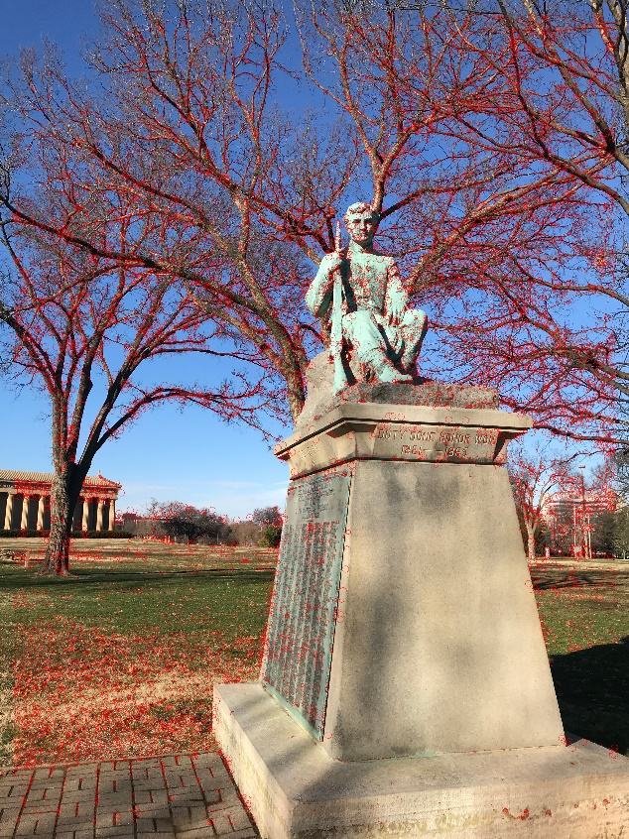

Figure 18. I_left marked with keypoints detected by STAR

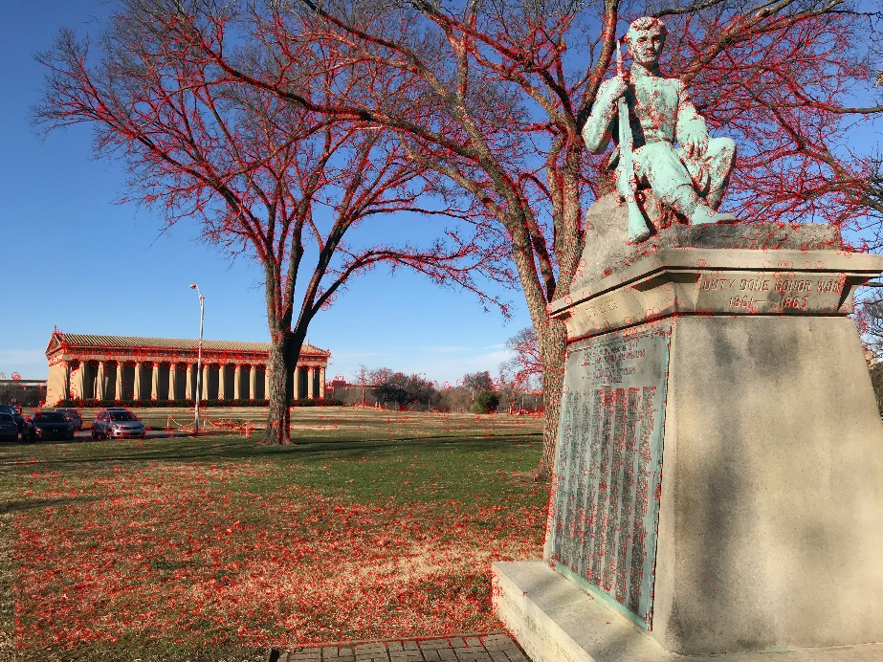

Figure 19. I_st marked with keypoints detected by STAR

The result of feature matching between the two images, after applying STAR on them to get the keypoints and BRIEF algorithm on them to get the descriptors, is shown in fig. 20.

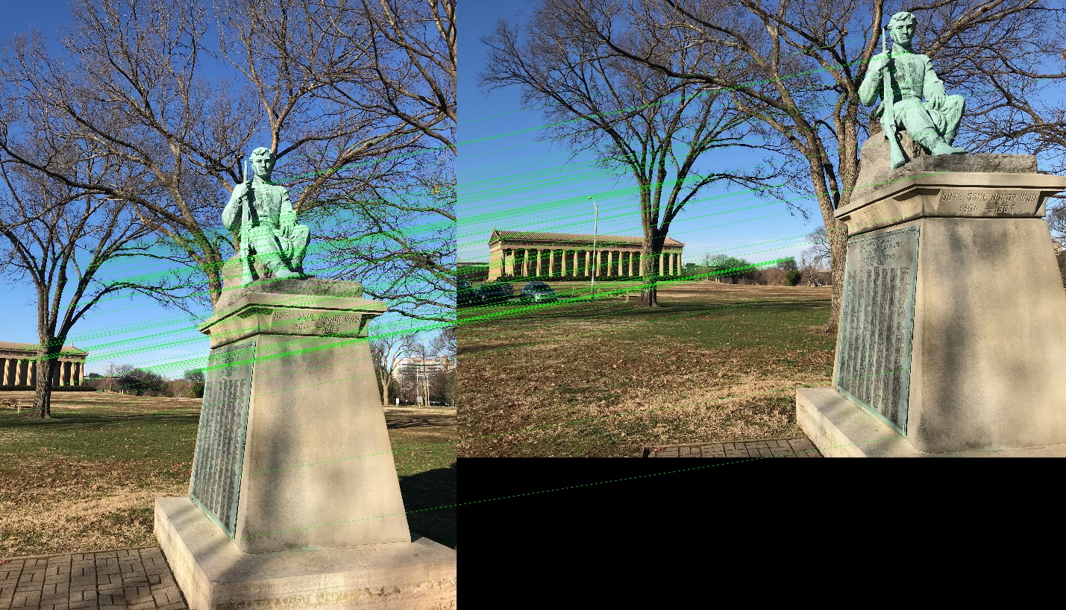

Figure. 20 Matching Between I_left and I_st after implementing BRIEF and CenSurE Algorithm

* 1. **Discussion of Results**

As BRIEF only generates descriptors, the keypoints in the images were generated by using the CenSurE algorithm. Using these keypoints, BRIEF generated the descriptors. Based on this, the matching performed by the combination of BRIEF and CenSurE using BFMatcher() was very good. Majority of the points matched accurately.

# ORB

**7.1 Description**

Oriented FAST and Rotated BRIEF, is a combination of the FAST algorithm for keypoint detection and BRIEF algorithm for determining the descriptors, along with modifications to further enhance the performance of the algorithm.

It computes the intensity weighted centroid of the patch with located corner at center. The direction of the vector from this corner point to centroid gives the orientation. To improve the rotation invariance, moments are computed with x and y which should be in a circular region of radius r, where r is the size of the patch.

Now for descriptors, ORB use BRIEF descriptors. But we have already seen that BRIEF performs poorly with rotation. So what ORB does is to "steer" BRIEF according to the orientation of keypoints. For any feature set of n binary tests at location (xi,yi), define a 2×n matrix, S which contains the coordinates of these pixels. Then using the orientation of patch, θ, its rotation matrix is found and rotates the S to get steered(rotated) version Sθ.

ORB discretize the angle to increments of 2π/30 (12 degrees), and construct a lookup table of precomputed BRIEF patterns. As long as the keypoint orientation θ is consistent across views, the correct set of points Sθ will be used to compute its descriptor.

OpenCV provides the function cv2.ORB () which creates object of ORB.

* 1. **Parameters Selection**

For this assignment the object for implementing the ORB algorithm was created with default parameter values as it provided the best result, other than MaxFeatures. MaxFeature parameter sets the maximum number of features detected and returned by ORB. For this assignment, Maxfeatures was set at 15000, to increase the number of features returned by ORB.

* 1. **Results**

The results of keypoint detection by ORB algorithm on the input images are shown in fig. 21 and fig. 22.

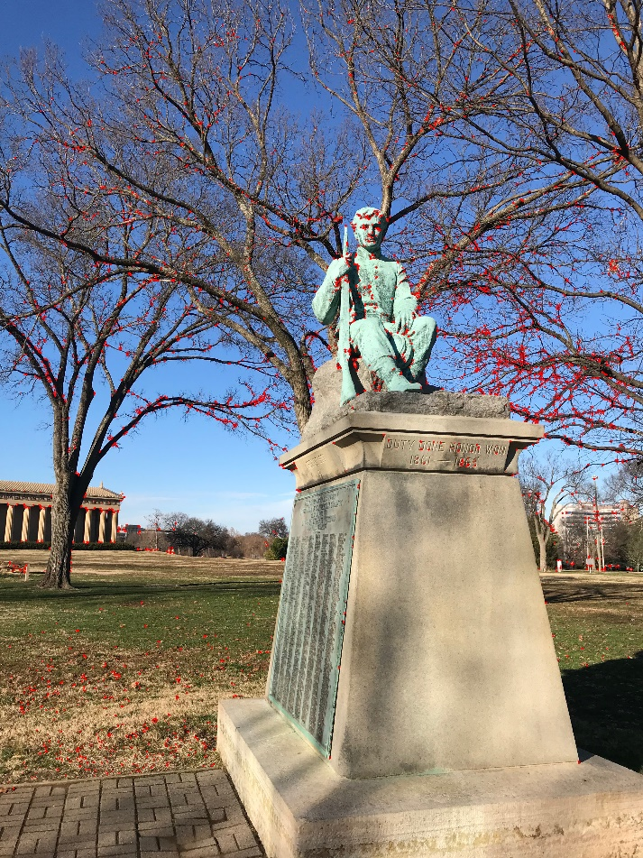

Figure 21. I_left marked with keypoints detected by ORB

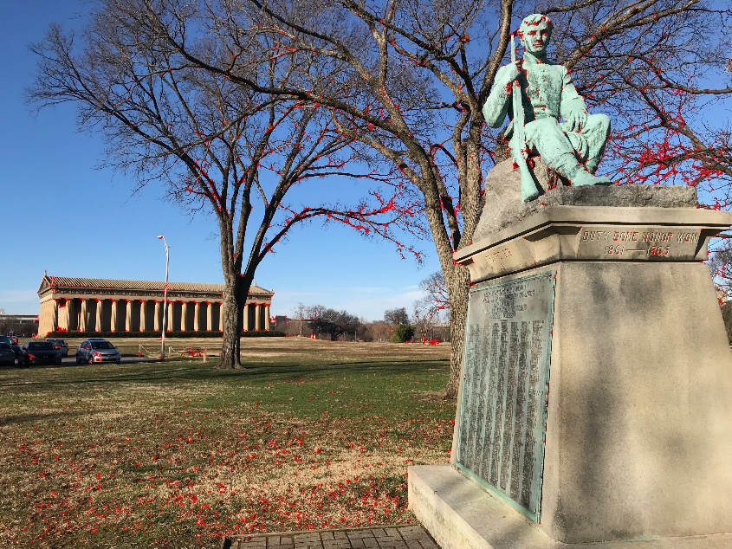

Figure 22. I_st marked with keypoints detected by ORB

The result of feature matching between the two images, after applying ORB on them to get the keypoints is shown in figure 23.

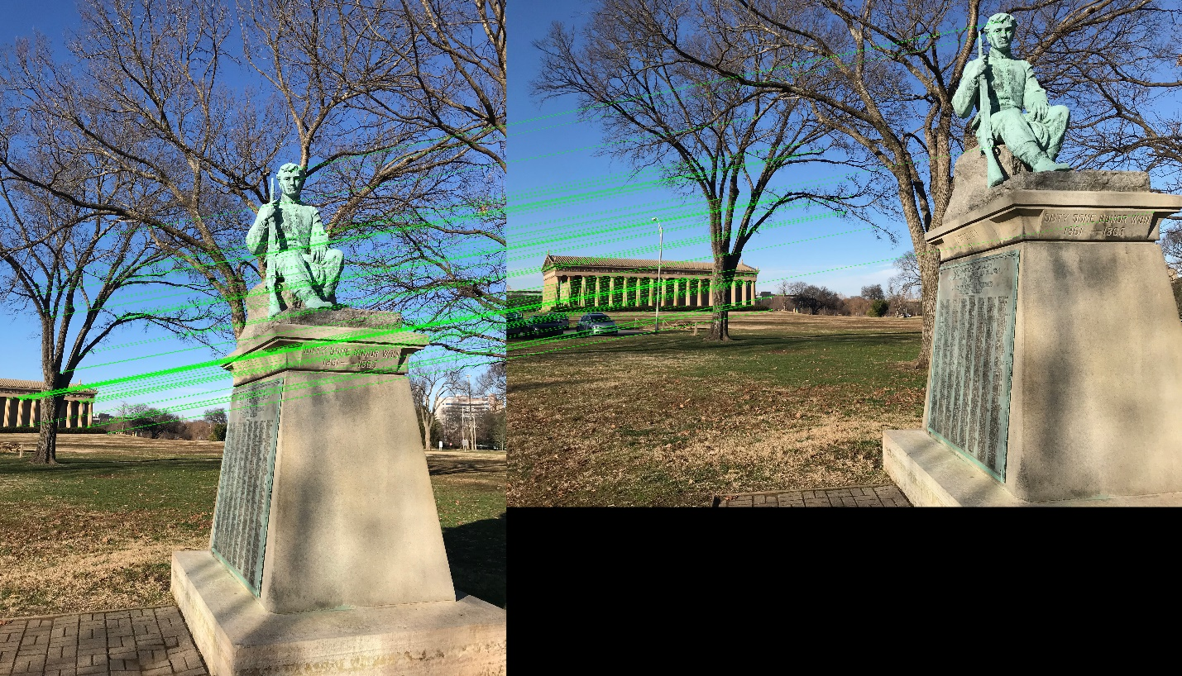

Figure. 23 Matching Between I_left and I_st after implementing ORB Algorithm

* 1. **Discussion of Results**

After analyzing the results generated by the ORB algorithm, it is evident that the ORB algorithm successfully detects the feature in the image, and provides very good matching results when used with BFMatcher(). It was also observed that the ORB algorithm provided the results in less time while providing almost identical results to SIFT and SURF.

# Handwriting Recognition using HoG

A very important feature descriptor used in computer vision is the Histogram of Oriented Gradients (HoG) feature Descriptor. The basic idea behind this algorithm is that local object appearance and shape can often be characterized rather well by the distribution of local intensity gradients or edge directions, even without precise knowledge of the corresponding gradient or edge positions.

The HoG feature Descriptor is used to implement a Handwriting Recognition application. To perform this part of the assignment we apply the HOG image descriptor and a Linear Support Vector Machine (SVM) to learn the representation of image digits. Four python scripts were written, namely ‘hog.py’, ‘dataset.py’, ‘train.py’ and ‘classify.py’ in-order to accomplish the task. The script ‘hog.py’ defines a class to implement the HoG descriptor. The script ‘dataset.py’ deﬁne some methods to help manipulate and prepare the dataset for feature extraction and for training the model. The script ‘train.py’ trains the machine learning model to recognize the digits. The script ‘classify.py’ classifies the digits in the image based on the model.

**Results**

The input image used for testing the Handwriting Recognizer is shown in fig.24.

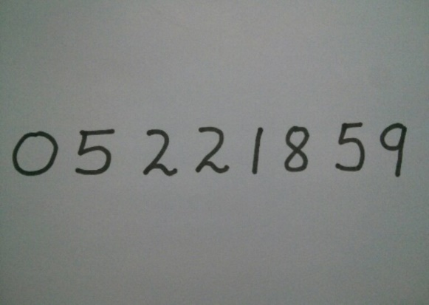

Figure 24. Input Image to the Handwriting Recognition Application

The Output Image from the Handwriting Recognition application is shown in fig. 25.

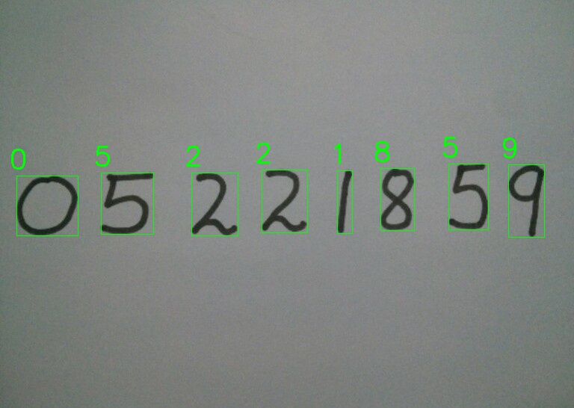

Figure 25. Output Image correctly recognizing the digits

**Discussion of Results**

It is evident from the results that the Handwriting Recognition with HoG is successfully recognizing the digits from the handwriting. It has also been observed that if the digits in the image are very large (more than a few hundred pixels across), then the program is not able to recognize the digits correctly, as it is not able to detect such large features and corners in the image.

# Conclusion

After analyzing and comparing the results from various feature detectors, it was observed that the results generated by ORB, SIFT, SURF were identical in terms of accuracy of matching, but ORB algorithm provided the best results. The rationale being that ORB generated the results in in less time than the other algorithms. The reason behind ORB’s speed is that it combines FAST and BRIEF algorithms, FAST for detection of keypoints and BRIEF for generation of descriptors, while further optimizing the performance.. From all the algorithms, the Shi -Tomasi Corner Detection algorithm provided the elast accurate results for matching when used with BFMatcher().

# Appendix – Python Code of the Assignment

**A.1 Code for Implementing Harris Corner Detection Algorithm and Matching**

**import** numpy **as** np  
**import** cv2 **as** cv  
**import** matplotlib.pyplot **as** plt  
  
I_left_org = cv.imread(**'IMG-6986.jpg'**)  
I_st_org = cv.imread(**'IMG-6987.jpg'**)  
I_left = I_left_org  
I_st = I_st_org  
  
gray = cv.cvtColor(I_left,cv.COLOR_BGR2GRAY)  
gray_st = cv.cvtColor(I_st,cv.COLOR_BGR2GRAY)  
  
gray = np.float32(gray)  
gray_st = np.float32(gray_st)  
SE = cv.getStructuringElement(2, (7,7))  
  
dst = np.clip(cv.cornerHarris(gray, 2, 3, 0.04),0 ,**None**)  
dst = cv.dilate(dst, SE, iterations=2)  
  
dst_st = np.clip(cv.cornerHarris(gray_st, 2, 3, 0.04),0 ,**None**)  
dst_st = cv.dilate(dst_st, SE, iterations=2)  
  
ret, dst = cv.threshold(dst, 0.01*dst.max(), 255, 0)  
dst = np.uint8(dst)  
  
ret_st, dst_st = cv.threshold(dst_st, 0.01*dst_st.max(), 255, 0)  
dst_st = np.uint8(dst_st)  
  
ret, labels, stats, centroids = cv.connectedComponentsWithStats(dst)  
ret_st, labels_st, stats_st, centroids_st = cv.connectedComponentsWithStats(dst_st)  
  
criteria = (cv.TERM_CRITERIA_EPS + cv.TERM_CRITERIA_MAX_ITER, 100, 0.001)  
corners = cv.cornerSubPix(gray, np.float32(centroids), (5, 5), (-1, -1), criteria)  
  
corners_st = cv.cornerSubPix(gray_st, np.float32(centroids_st), (5, 5), (-1, -1), criteria)  
  
res = np.hstack((centroids, corners))  
res = np.int0(res)  
I_left[res[:,1],res[:,0]] = [0, 0, 255]  
I_left[res[:,3],res[:,2]] = [0, 255, 0]  
  
res_st = np.hstack((centroids_st, corners_st))  
res_st = np.int0(res_st)  
I_st[res_st[:,1],res_st[:,0]] = [0, 0, 255]  
I_st[res_st[:,3],res_st[:,2]] = [0, 255, 0]  
  
corners = np.int0(corners)  
corners_st = np.int0(corners_st)  
  
**for** i **in** corners:  
 x,y = i.ravel()  
 cv.circle(I_left,(x,y), 10,(0, 0, 255),4)  
  
**for** i **in** corners_st:  
 x,y = i.ravel()  
 cv.circle(I_st, (x,y), 10, (0, 0, 255), 4)  
  
  
plt.imshow(cv.cvtColor(I_left,cv.COLOR_BGR2RGB)), plt.title(**'After Image'**), plt.show()  
plt.imshow(cv.cvtColor(I_st, cv.COLOR_BGR2RGB)), plt.title(**'Features St'**), plt.show()  
  
cv.imwrite(**'Feature_Harris_statue_left.png'**,I_left)  
cv.imwrite(**'Features_Harris_statue_st.png'**, I_st)  
  
diam = 7  
nbhd = np.zeros((diam, diam))  
nbhd_st = np.zeros((diam,diam))  
n_start = np.floor(diam/2)  
n_stop = np.floor((diam+1)/2)  
xdist = 120  
ydist = 30  
minsim = 0.7  
  
left_keypoints = []  
right_keypoints = []  
  
left_descriptors = []  
right_descriptors = []  
  
n = len(corners)  
n_st = len(corners_st)  
  
**for** c **in** range(0,n):  
 x = corners[c,0]  
 y = corners[c,1]  
 **if** x>diam **and** y >diam:  
 left_keypoints.append(cv.KeyPoint(x, y, _size = diam, _response = 0))  
 nbhd = I_left[np.int32(y-n_start):np.int32(y+n_stop), np.int32(x-n_start):np.int32(x+n_stop)]  
 desc = nbhd.flatten()-np.mean(nbhd)  
 left_descriptors.append(desc)  
  
**for** c **in** range(0,n_st):  
 x = corners_st[c,0]  
 y = corners_st[c,1]  
 **if** x>=diam **and** y >= diam:  
 right_keypoints.append(cv.KeyPoint(x, y, _size = diam, _response = 0))  
 nbhd_st = I_st[np.int32(y-n_start):np.int32(y+n_stop), np.int32(x-n_start):np.int32(x+n_stop)]  
 desc = nbhd_st.flatten()-np.mean(nbhd_st)  
 right_descriptors.append(desc)  
  
right_descriptors = np.array(right_descriptors)  
left_descriptors = np.array(left_descriptors)  
  
nlkp = len(left_keypoints)  
nrkp = len(right_keypoints)  
  
kp_sim_mat = np.zeros((nlkp, nrkp), dtype=np.float32)  
  
**for** lkp **in** range(nlkp):  
 lx, ly = np.int32(left_keypoints[lkp].pt)  
 left_desc = left_descriptors[lkp]  
 left_desc = left_desc[:100]  
 left_norm = np.linalg.norm(left_desc)  
  
  
 **for** rkp **in** range(nrkp):  
 rx, ry = np.int32(right_keypoints[rkp].pt)  
 **if** np.abs(ry - ly)<ydist **and** np.abs(rx-lx)<xdist:  
 right_desc = right_descriptors[rkp]  
 right_desc = right_desc[:100]  
 right_norm = np.linalg.norm(right_desc)  
 sim = np.dot(left_desc, right_desc)/(left_norm*right_norm)  
 **if** sim>minsim:  
 kp_sim_mat[lkp,rkp] = sim  
  
lefts_best_right = np.zeros((nlkp, 2))  
rights_best_left = np.zeros((nrkp,2))  
  
**for** lkp **in** range(nlkp):  
 req_row = kp_sim_mat[lkp, :]  
 **if** np.any(req_row):  
 ind = np.argmax(req_row)  
 lefts_best_right[lkp,0] = ind  
 lefts_best_right[lkp, 1] = req_row[ind]  
  
**for** rkp **in** range(nrkp):  
 req_col = kp_sim_mat[:, rkp]  
 **if** np.any(req_col):  
 ind = np.argmax(req_col)  
 rights_best_left[rkp, 0] = ind  
 rights_best_left[rkp, 1] = req_col[ind]  
  
*# Finding consistent matches*matches = []  
  
**for** i **in** range(nlkp):  
 m = lefts_best_right[i, 0]  
 m = np.uint32(m)  
 j = np.uint32(rights_best_left[m, 0])  
 **if** j == i:  
 matches.append(cv.DMatch(i, j, _distance=(1/lefts_best_right[i,1])))  
  
matches = sorted(matches, key = **lambda** x:x.distance)  
  
Match_I = cv.drawMatches(I_left, left_keypoints, I_st, right_keypoints, matches[:10], **None**, matchColor=(0, 255, 0), flags=2)  
  
plt.imshow(cv.cvtColor(Match_I,cv.COLOR_BGR2RGB)), plt.title(**'Matching'**), plt.show()  
cv.imwrite(**'Matching_Statue_Harris.png'**, Match_I)  
  
**A.2 Code for Implementing Shi-Tomasi Corner Detection Algorithm and Matching**

**import** numpy **as** np  
**import** cv2 **as** cv  
**from** matplotlib **import** pyplot **as** plt  
  
I_left_org = cv.imread(**'IMG-6986.jpg'**)  
I_st_org = cv.imread(**'IMG-6987.jpg'**)  
  
I_left = I_left_org  
I_st = I_st_org  
  
gray = cv.cvtColor(I_left, cv.COLOR_BGR2GRAY)  
gray_st = cv.cvtColor(I_st, cv.COLOR_BGR2GRAY)  
  
corners = cv.goodFeaturesToTrack(gray, 1000, 0.1, 50)  
corners_st = cv.goodFeaturesToTrack(gray_st, 1000, 0.1, 50)  
  
print(corners_st.shape)  
  
corners = np.int0(corners)  
corners_st = np.int0(corners_st)  
  
**for** i **in** corners:  
 x,y = i.ravel()  
 cv.circle(I_left,(x,y), 10,(0, 0, 255), 4)  
  
**for** i **in** corners_st:  
 x,y = i.ravel()  
 cv.circle(I_st, (x,y), 10, (0, 0, 255), 4)  
  
plt.imshow(cv.cvtColor(I_left,cv.COLOR_BGR2RGB)), plt.show()  
plt.imshow(cv.cvtColor(I_st,cv.COLOR_BGR2RGB)), plt.show()  
  
cv.imwrite(**'Features-Shi-left.png'**, I_left)  
cv.imwrite(**'Features-Shi-St.png'**, I_st)  
*# plt.imsave('image',I_left)*diam = 7  
nbhd = np.zeros((diam, diam))  
nbhd_st = np.zeros((diam,diam))  
n_start = np.floor(diam/2)  
n_stop = np.floor((diam+1)/2)  
xdist = 120  
ydist = 30  
minsim = 0.7  
  
*#corners = corners.reshape(corners.shape[0], (corners.shape[1]*corners.shape[2]))*left_keypoints = []  
right_keypoints = []  
  
left_descriptors = []  
right_descriptors = []  
  
n = len(corners)  
n_st = len(corners_st)  
  
**for** c **in** range(0,n):  
 x = corners[c,0,0]  
 y = corners[c,0,1]  
 **if** x>diam **and** y >diam:  
 left_keypoints.append(cv.KeyPoint(x, y, _size = diam, _response = 0))  
 nbhd = I_left[np.int32(y-n_start):np.int32(y+n_stop), np.int32(x-n_start):np.int32(x+n_stop)]  
 desc = nbhd.flatten()-np.mean(nbhd)  
 left_descriptors.append(desc)  
  
**for** c **in** range(0,n_st):  
 x = corners_st[c,0,0]  
 y = corners_st[c,0,1]  
 **if** x>=diam **and** y >= diam:  
 right_keypoints.append(cv.KeyPoint(x, y, _size = diam, _response = 0))  
 nbhd_st = I_st[np.int32(y-n_start):np.int32(y+n_stop), np.int32(x-n_start):np.int32(x+n_stop)]  
 desc = nbhd_st.flatten()-np.mean(nbhd_st)  
 right_descriptors.append(desc)  
  
right_descriptors = np.array(right_descriptors)  
left_descriptors = np.array(left_descriptors)  
  
nlkp = len(left_keypoints)  
nrkp = len(right_keypoints)  
  
kp_sim_mat = np.zeros((nlkp, nrkp), dtype=np.float32)  
  
**for** lkp **in** range(nlkp):  
 lx, ly = np.int32(left_keypoints[lkp].pt)  
 left_desc = left_descriptors[lkp]  
 left_desc = left_desc[:100]  
 left_norm = np.linalg.norm(left_desc)  
  
  
 **for** rkp **in** range(nrkp):  
 rx, ry = np.int32(right_keypoints[rkp].pt)  
 **if** np.abs(ry - ly)<ydist **and** np.abs(rx-lx)<xdist:  
 *# Can get the dimensions of the smaller and make adjustments accordingly* right_desc = right_descriptors[rkp]  
 right_desc = right_desc[:100]  
 right_norm = np.linalg.norm(right_desc)  
 sim = np.dot(left_desc, right_desc)/(left_norm*right_norm)  
 **if** sim>minsim:  
 kp_sim_mat[lkp,rkp] = sim  
  
lefts_best_right = np.zeros((nlkp, 2))  
rights_best_left = np.zeros((nrkp,2))  
  
**for** lkp **in** range(nlkp):  
 req_row = kp_sim_mat[lkp, :]  
 **if** np.any(req_row):  
 ind = np.argmax(req_row)  
 lefts_best_right[lkp,0] = ind  
 lefts_best_right[lkp, 1] = req_row[ind]  
  
**for** rkp **in** range(nrkp):  
 req_col = kp_sim_mat[:, rkp]  
 **if** np.any(req_col):  
 ind = np.argmax(req_col)  
 rights_best_left[rkp, 0] = ind  
 rights_best_left[rkp, 1] = req_col[ind]  
  
*# Finding consistent matches*matches = []  
  
**for** i **in** range(nlkp):  
 m = lefts_best_right[i, 0]  
 m = np.uint32(m)  
 j = np.uint32(rights_best_left[m, 0])  
 **if** j == i:  
 matches.append(cv.DMatch(i, j, _distance=lefts_best_right[i,1]))  
  
matches = sorted(matches, key = **lambda** x:x.distance)  
  
Match_I = cv.drawMatches(I_left, left_keypoints, I_st, right_keypoints, matches[:10], **None**, matchColor=(0, 255, 0), flags=2)  
  
plt.imshow(cv.cvtColor(Match_I,cv.COLOR_BGR2RGB)), plt.title(**'Matching'**), plt.show()  
cv.imwrite(**'Matching_Statue_Shi_Tomasi.png'**, Match_I)

**A.3 Code for Implementing SIFT Algorithm and Matching**

**import** numpy **as** np  
**import** cv2 **as** cv  
**from** matplotlib **import** pyplot **as** plt  
  
I_left = cv.imread(**'IMG-6986.jpg'**)  
gray = cv.cvtColor(I_left,cv.COLOR_BGR2GRAY)  
  
I_st = cv.imread(**'IMG-6987.jpg'**)  
gray_st = cv.cvtColor(I_st,cv.COLOR_BGR2GRAY)  
  
*#sift = cv.xfeatures2d.SIFT_create()*sift = cv.xfeatures2d.SIFT_create(contrastThreshold=0.16, sigma= 1.2)  
kp = sift.detect(gray, **None**)  
kp_st = sift.detect(gray_st, **None**)  
  
I_left = cv.drawKeypoints(gray, kp, I_left)  
I_st = cv.drawKeypoints(gray_st, kp_st, I_st)  
  
kp, des = sift.compute(gray, kp)  
kp_st, des_st = sift.compute(gray_st, kp_st)  
  
I_left = cv.drawKeypoints(gray, kp, I_left, flags=cv.DRAW_MATCHES_FLAGS_DRAW_RICH_KEYPOINTS)  
I_st = cv.drawKeypoints(gray_st, kp_st, I_st, flags=cv.DRAW_MATCHES_FLAGS_DRAW_RICH_KEYPOINTS)  
  
*#plt.imshow(cv.cvtColor(I_left,cv.COLOR_BGR2RGB)), plt.show()  
#plt.imshow(cv.cvtColor(I_st,cv.COLOR_BGR2RGB)), plt.show()  
  
#plt.imshow(I_left), plt.show()  
#plt.imshow(I_st), plt.show()*cv.imwrite(**'Features_sift_statue_left.png'**, I_left)  
cv.imwrite(**'Features_sift_statue_st.png'**, I_st)  
  
bf = cv.BFMatcher()  
matches = bf.match(des, des_st)  
  
matches = sorted(matches, key=**lambda** x:x.distance)  
  
I_match = cv.drawMatches(I_left, kp, I_st, kp_st, matches[:100], **None**, flags =2)  
plt.imshow(cv.cvtColor(I_match,cv.COLOR_BGR2RGB)), plt.title(**'Matching'**), plt.show()  
  
cv.imwrite(**'Matching_SIFT_Statue.png'**, I_match)

**A.4 Code for Implementing SURF Algorithm and Matching**

**import** numpy **as** np  
**import** cv2 **as** cv  
**from** matplotlib **import** pyplot **as** plt  
  
I_left = cv.imread(**'IMG-6986.jpg'**)  
I_st = cv.imread(**'IMg-6987.jpg'**)  
  
surf = cv.xfeatures2d.SURF_create()  
surf.setHessianThreshold(5000)  
  
print(**'Hessian threshold: {}'**.format(surf.getHessianThreshold()))  
  
kp, des = surf.detectAndCompute(I_left, **None**)  
kp_st, des_st = surf.detectAndCompute(I_st, **None**)  
  
I_left = cv.drawKeypoints(I_left, kp, **None**, (0, 0, 255), 4)  
I_st = cv.drawKeypoints(I_st, kp_st, **None**, (0, 0, 255), 4)  
  
*#plt.imshow(I_left), plt.show()  
#plt.imshow(I_st), plt.show()*plt.imshow(cv.cvtColor(I_left,cv.COLOR_BGR2RGB)), plt.show()  
plt.imshow(cv.cvtColor(I_st,cv.COLOR_BGR2RGB)), plt.show()  
  
cv.imwrite(**'Features_SURF_statue_Left.png'**, I_left)  
cv.imwrite(**'Features_SURF_statue_st.png'**, I_st)  
  
bf = cv.BFMatcher()  
matches = bf.match(des, des_st)  
  
matches = sorted(matches, key=**lambda** x:x.distance)  
  
I_match = cv.drawMatches(I_left, kp, I_st, kp_st, matches[:100], **None**, flags =2)  
plt.imshow(cv.cvtColor(I_match,cv.COLOR_BGR2RGB)),plt.title(**'Matching'**), plt.show()  
cv.imwrite(**'Matching_statue_SURF.png'**, I_match)

**A.5 Code for Implementing FAST Algorithm and Matching**

**import** numpy **as** np  
**import** cv2 **as** cv  
**from** matplotlib **import** pyplot **as** plt  
  
I_left = cv.imread(**'IMG-6986.jpg'**)  
I_st = cv.imread(**'IMG-6987.jpg'**)  
  
fast = cv.FastFeatureDetector_create()  
fast.setThreshold(80)  
  
kp = fast.detect(I_left, **None**)  
kp_st = fast.detect(I_st, **None**)  
  
I_left = cv.drawKeypoints(I_left, kp, **None**, (0, 0, 255), 4)  
I_st = cv.drawKeypoints(I_st, kp_st, **None**, (0, 0, 255), 4)  
  
*# FAST is a keypoint detector and hence does not compute descriptors  
# Descriptors need to be computed by some other function  
# We will try Brief here*brief = cv.xfeatures2d.BriefDescriptorExtractor_create()  
kp, des = brief.compute(I_left, kp)  
kp_st, des_st = brief.compute(I_st, kp_st)  
  
print(**'Threshold :{}'**.format(fast.getThreshold()))  
print(**'Total Keypoints left : {}'**.format(len(kp)))  
print(**'Neighborhood: {}'**.format(fast.getType()))  
print(**'Total Keypoints st : {}'**.format(len(kp_st)))  
print(**'Non Maximal suppression: {}'**.format(fast.getNonmaxSuppression()))  
  
plt.imshow(cv.cvtColor(I_left, cv.COLOR_BGR2RGB)), plt.title(**'Threshold = {}'**.format(fast.getThreshold())), plt.show()  
plt.imshow(cv.cvtColor(I_st, cv.COLOR_BGR2RGB)), plt.title(**'St_Image, Threshold= {}'**.format(fast.getThreshold())), plt.show()  
  
cv.imwrite(**'Features_FAST_statue_left.png'**, I_left)  
cv.imwrite(**'Features_FAST_statue_st.png'**, I_st)  
  
bf = cv.BFMatcher(cv.NORM_HAMMING, crossCheck = **True**)  
matches = bf.match(des, des_st)  
  
matches = sorted(matches, key = **lambda** x:x.distance)  
  
Match_I = cv.drawMatches(I_left, kp, I_st, kp_st, matches[:10], **None**, matchColor=(0, 255, 0), flags=2)  
  
plt.imshow(cv.cvtColor(Match_I,cv.COLOR_BGR2RGB)), plt.title(**'Matching'**), plt.show()  
cv.imwrite(**'Matching_Statue_FAST.png'**, Match_I)  
  
*# fast.setNonmaxSuppression(0)  
# kp = fast.detect(I_left, None)  
# I_left = cv.drawKeypoints(I_left, kp, None, (0, 0, 255), 4)  
#  
# plt.imshow(cv.cvtColor(I_left, cv.COLOR_BGR2RGB)), plt.show()*

**A.6 Code for Implementing BRIEF Algorithm and Matching**

**import** numpy **as** np  
**import** cv2 **as** cv  
**from** matplotlib **import** pyplot **as** plt  
  
I_left = cv.imread(**'IMG-6986.jpg'**)  
I_st = cv.imread(**'IMG-6987.jpg'**)  
  
star = cv.xfeatures2d.StarDetector_create()  
  
brief = cv.xfeatures2d.BriefDescriptorExtractor_create()  
  
kp = star.detect(I_left, **None**)  
kp_st = star.detect(I_st, **None**)  
  
I_left = cv.drawKeypoints(I_left, kp, **None**, (0, 0, 255), 4)  
I_st = cv.drawKeypoints(I_st, kp_st, **None**, (0, 0, 255), 4)  
  
kp, des = brief.compute(I_left, kp)  
kp_st, des_st = brief.compute(I_st, kp_st)  
  
print(**'Descriptor Size from Brief: {}'**.format(brief.descriptorSize()))  
print(**'Descriptor shape for left Image: {}'**.format(des.shape))  
print(**'Descriptor shape for st Image: {}'**.format(des_st.shape))  
  
plt.imshow(cv.cvtColor(I_left, cv.COLOR_BGR2RGB)), plt.title(**'Left Image with KeyPoints'**), plt.show()  
plt.imshow(cv.cvtColor(I_st, cv.COLOR_BGR2RGB)), plt.title(**'St Image with KeyPoints'**), plt.show()  
  
cv.imwrite(**'Features_Star_Brief_left_Statue.png'**, I_left)  
cv.imwrite(**'Features_Star_Brief_st_Statue.png'**, I_st)  
  
bf = cv.BFMatcher(cv.NORM_HAMMING, crossCheck=**True**)  
matches = bf.match(des, des_st)  
  
matches = sorted(matches, key=**lambda** x:x.distance)  
  
Match_I = cv.drawMatches(I_left, kp, I_st, kp_st, matches[:10], **None**, matchColor=(0, 255, 0), flags=2)  
  
plt.imshow(cv.cvtColor(Match_I,cv.COLOR_BGR2RGB)), plt.title(**'Matching'**), plt.show()  
cv.imwrite(**'Matching_Statue_Brief_Star.png'**, Match_I)

**A.7 Code for Implementing ORB Algorithm and Matching**

**import** numpy **as** np  
**import** cv2 **as** cv  
**from** matplotlib **import** pyplot **as** plt  
  
I_left = cv.imread(**'IMG-6986.jpg'**)  
I_st = cv.imread(**'IMG-6987.jpg'**)  
  
orb = cv.ORB_create()  
*#orb.setMaxFeatures(5000)*kp = orb.detect(I_left, **None**)  
kp_st = orb.detect(I_st, **None**)  
  
kp, des = orb.compute(I_left, kp)  
kp_st, des_st = orb.compute(I_st, kp_st)  
  
I_left = cv.drawKeypoints(I_left, kp, **None**, (0, 0, 255), 0)  
I_st = cv.drawKeypoints(I_st, kp_st, **None**, (0, 0, 255), 0)  
print(**'No. of Keypoints in Left: {}'**.format(len(kp)))  
print(**'No. of Keypoints in st: {}'**.format(len(kp_st)))  
  
plt.imshow(cv.cvtColor(I_left, cv.COLOR_BGR2RGB)), plt.title(**'Orb_Features with draw flag = 0, Left Image'**), plt.show()  
plt.imshow(cv.cvtColor(I_st, cv.COLOR_BGR2RGB)), plt.title(**'Orb_features with draw flag = 0, St Image'**), plt.show()  
  
cv.imwrite(**'Features_Orb_Statue_Left.png'**, I_left)  
cv.imwrite(**'Features_Orb_Statue_St.png'**, I_st)  
  
bf = cv.BFMatcher(cv.NORM_HAMMING, crossCheck = **True**)  
matches = bf.match(des, des_st)  
  
matches = sorted(matches, key = **lambda** x:x.distance)  
  
Match_I = cv.drawMatches(I_left, kp, I_st, kp_st, matches[:10], **None**, matchColor=(0, 255, 0), flags=2)  
  
plt.imshow(cv.cvtColor(Match_I,cv.COLOR_BGR2RGB)), plt.title(**'Matching'**), plt.show()  
cv.imwrite(**'Matching_Statue_ORB.png'**, Match_I)

**A.8 Code for Handwriting Recognition with HoG (Graduate Part)**

**‘hog.py’**

**from** skimage **import** feature  
  
**class** HOG:  
 **def** __init__(self, orientations = 9, pixelsPerCell =(8, 8),  
 cellsPerBlock =(3,3), transform = **False**):  
 self.orientations = orientations  
 self.pixelsPerCell = pixelsPerCell  
 self.cellsPerBlock = cellsPerBlock  
 self.transform = transform  
  
 **def** describe(self, image):  
 hist = feature.hog(image, orientations = self.orientations,  
 pixels_per_cell=self.pixelsPerCell,  
 cells_per_block=self.cellsPerBlock,  
 transform_sqrt=self.transform)  
 **return** hist

**‘dataset.py’**

**import** imutils  
**import** numpy **as** np  
**import** mahotas  
**import** cv2 **as** cv  
  
**def** load_digits(datasetPath):  
 data = np.genfromtxt(datasetPath, delimiter = **","**,  
 dtype=**"uint8"**)  
 target = data[:, 0]  
 data = data[:,1:].reshape(data.shape[0], 28, 28)  
  
 **return** (data, target)  
  
**def** deskew(image, width):  
 (h, w) = image.shape[:2]  
 moments = cv.moments(image)  
  
 skew = moments[**"mu11"**] / moments[**"mu02"**]  
 M = np.float32([[1, skew, -0.5 * w * skew], [0, 1, 0]])  
 image = cv.warpAffine(image, M, (w, h),  
 flags= cv.WARP_INVERSE_MAP | cv.INTER_LINEAR)  
  
 image = imutils.resize(image, width = width)  
 **return** image  
  
**def** center_extent(image, size):  
 (eW, eH) = size  
  
 **if** image.shape[1] > image.shape[0]:  
 image = imutils.resize(image, width=eW)  
  
 **else**:  
 image = imutils.resize(image, height=eH)  
  
 extent = np.zeros((eH, eW), dtype=**"uint8"**)  
 offsetX = (eW - image.shape[1]) // 2  
 offsetY = (eH - image.shape[0]) // 2  
 extent[offsetY:offsetY + image.shape[0], offsetX:offsetX + image.shape[1]] = image  
  
 CM = mahotas.center_of_mass(extent)  
 (cY, cX) = np.round((CM).astype(**"int32"**))  
 (dX, dY) = ((size[0] // 2) - cX, (size[1] // 2 -cY))  
 M = np.float32([[1, 0, dX], [0, 1, dY]])  
 extent = cv.warpAffine(extent, M, size)  
  
 **return** extent

**‘train.py’**

**from** sklearn.externals **import** joblib  
**from** sklearn.svm **import** LinearSVC  
**from** hog **import** HOG  
**import** dataset  
**import** argparse  
  
ap = argparse.ArgumentParser()  
ap.add_argument(**"-d"**, **"--dataset"**, required=**True**,  
 help=**"path to the dataset file"**)  
ap.add_argument(**"-m"**, **"--model"**, required=**True**,  
 help=**"path to where the model will be stored"**)  
args = vars(ap.parse_args())  
  
(digits, target) = dataset.load_digits(args[**"dataset"**])  
data = []  
  
hog = HOG(orientations = 18, pixelsPerCell=(10, 10),  
 cellsPerBlock=(1, 1), transform=**True**)  
  
**for** image **in** digits:  
 image = dataset.deskew(image, 20)  
 image = dataset.center_extent(image, (20,20))  
  
 hist = hog.describe(image)  
 data.append(hist)  
  
model = LinearSVC(random_state=42)  
model.fit(data, target)  
  
joblib.dump(model, args[**"model"**])

**‘classify.py’**

**from** __future__ **import** print_function  
**from** sklearn.externals **import** joblib  
**from** hog **import** HOG  
**import** dataset  
**import** argparse  
**import** mahotas  
**import** cv2 **as** cv  
**import** matplotlib.pyplot **as** plt  
  
ap = argparse.ArgumentParser()  
ap.add_argument(**"-m"**, **"--model"**, required=**True**,  
 help=**"path to where the model will be stored"**)  
ap.add_argument(**"-i"**, **"--image"**, required=**True**,  
 help=**"path to the image file"**)  
args = vars(ap.parse_args())  
  
model = joblib.load(args[**"model"**])  
  
hog = HOG(orientations=18, pixelsPerCell=(10,10), cellsPerBlock=(1,1),  
 transform=**True**)  
  
image = cv.imread(args[**"image"**])  
gray = cv.cvtColor(image, cv.COLOR_BGR2GRAY)  
  
blurred = cv.GaussianBlur(gray, (5,5), 0)  
edged = cv.Canny(blurred, 30, 150)  
(_, cnts, _) = cv.findContours(edged.copy(), cv.RETR_EXTERNAL,  
 cv.CHAIN_APPROX_SIMPLE)  
  
cnts = sorted([(c, cv.boundingRect(c)[0]) **for** c **in** cnts], key =  
 **lambda** x: x[1])  
  
**for** (c, _) **in** cnts:  
 (x, y, w, h) = cv.boundingRect(c)  
  
 **if** w>= 7 **and** h>=20:  
 roi = gray[y:y + h, x:x + w]  
 thresh = roi.copy()  
 T = mahotas.thresholding.otsu(roi)  
 thresh[thresh > T] = 255  
 thresh = cv.bitwise_not(thresh)  
  
 thresh = dataset.deskew(thresh, 20)  
 thresh = dataset.center_extent(thresh, (20, 20))  
  
 cv.imshow(**"thresh"**, thresh)  
 hist = hog.describe(thresh)  
 digit = model.predict([hist])[0]  
 print(**"I think that number is: {}"**.format(digit))  
  
 cv.rectangle(image, (x, y), (x+w, y+h),  
 (0, 255, 0), 1)  
 cv.putText(image, str(digit), (x - 10, y - 10),  
 cv.FONT_HERSHEY_SIMPLEX, 1.2, (0, 255, 0), 2)  
 cv.imshow(**"image"**, image)  
 cv.waitKey(0)  
 *#plt.imshow(image), plt.title('Image'), plt.show()*cv.imwrite(**'image1.jpg'**, image)

**END REPORT**

**Thank You**